Scripting Task
Task Description:

- Create a shell script to print the HTTP error code of guvi.in & print, the success/failure message based on the error code response

Offline execution:
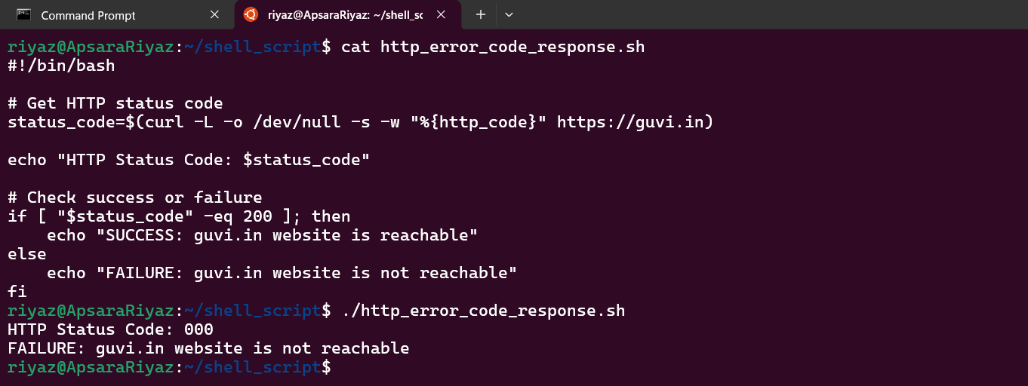Online Execution:
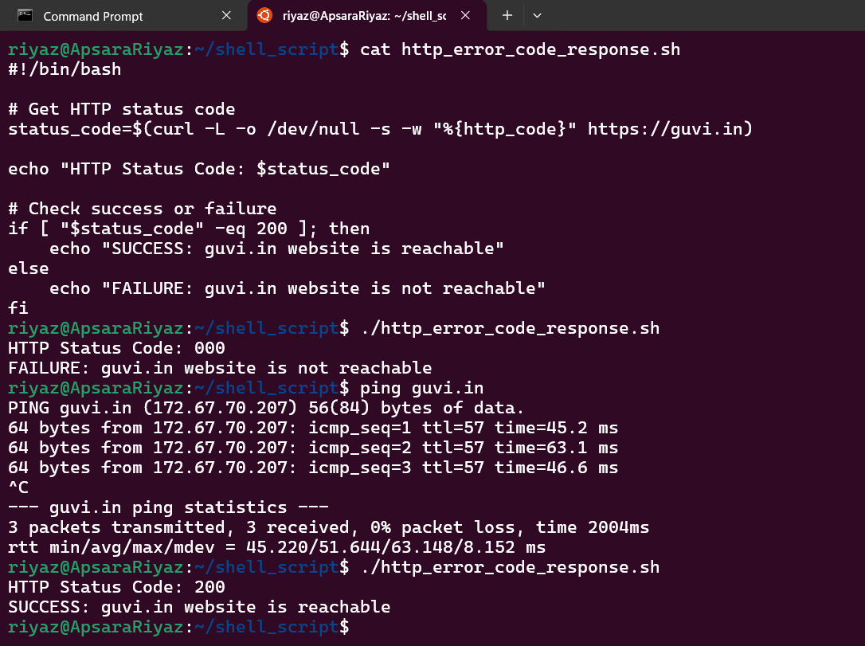

2.Given a file, replace all occurrence of the word "give" with "learning" from 5th line till the end in only those lines that contain the word "welcome"
